## Data Analysis

Measurements from each pipe were grouped together. For every data point taken, pressure drop per length of pipe was calculated from the measured pressure drop and the measured distance between the pressure sensing probes. To determine pipe diameter, the pipe circumference was measured and converted to an outside diameter, or a nominal pipe diameter was read from the pipe. This was referenced with literature to obtain the inner diameter of the pipe (which is the diameter used in all referenced equations). For each data point, an average fluid velocity was calculated from the measured flow rate and the inner pipe diameter. Shear stress was calculated using equation (2) and the calculated pressure drop per length of pipe. With this information, ln(τ) [ln(shear stress)] and ln(v) [ln(velocity)] were calculated.

Linear regressions were performed on ln(τ) and ln(v) (in the form of equation (3)). The slope of the regressed line was taken to be a measured value of n. The measured value of n was used to calculate Ω (defined in equation 4). The exponential of the difference between the intercept and Ω was taken to be a measurement of K. In this manner, K and n values were generated for both pipes. For convenience, equation 4 is repeated here.

|  |  |  |
| --- | --- | --- |
|  | $$Ω=n\ln\left(\frac{2\left(3n+1\right)}{nD}\right)$$ | (4) |

|  |  |  |  |
| --- | --- | --- | --- |
|  |  |  |  |
|  |  |  | Ω |

Another linear regression was performed to reconcile the data on the assumption that the true n and K values were the same for the fluid in both pipes (which should be true for a power law fluid.) In order to do this, a linear regression of ln(τ) - Ω versus ln(v) was used instead of the original in order to use all of the data as a whole.

|  |  |  |  |
| --- | --- | --- | --- |
| $$y$$ | $$m$$ | $$x$$ | $$b$$ |
| $ln\left(τ\right)-Ω$ | $$n$$ | $$ln(v)$$ | $$ln\left(K\right)$$ |

To obtain Ω, the pipe diameter corresponding to each data point was used, and n was calculated iteratively. Residuals were plotted as well. 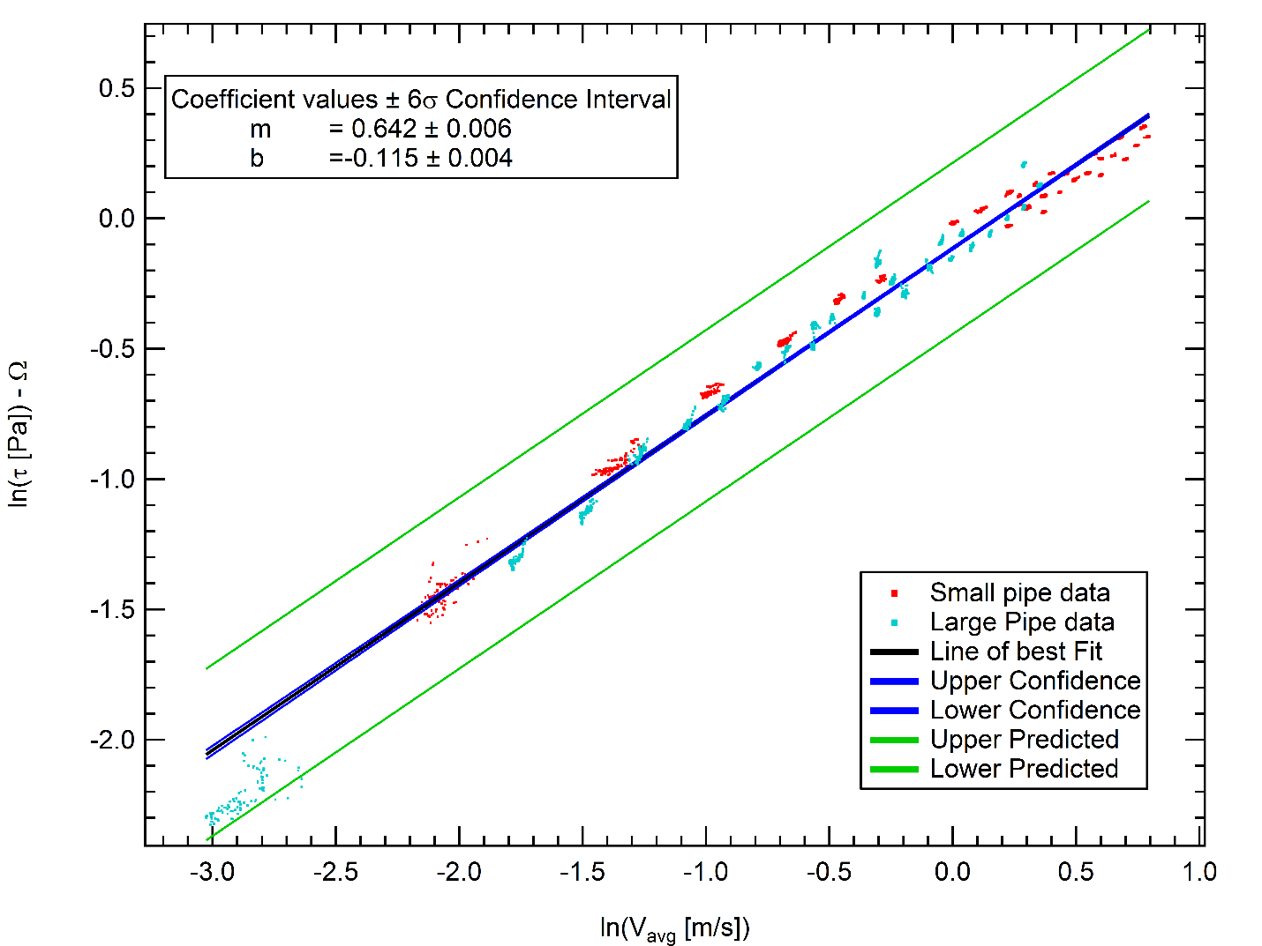

There was some initial concern about the cluster of data in the bottom left of both plots. These points correspond to very low flow rates in the large pipe. The data was taken to ensure that the pressure/shear relation went to zero in the limit of no flow, and was taken at a much lower flow rate than the rest of the data. Errors here are magnified due to the nature of logarithms.

The Reynolds numbers were also calculated once values of n and K were known. The Reynolds numbers for various flows in the small pipe ranged between 280 and 920, while the large pipe had Reynolds numbers between 115 and 400. The projected Reynolds number for the existing system at the specified flow rate (75 gpm) would be about 950. It would be better to operate the test at Reynolds numbers around the Reynolds number of the system, but the pump in the test apparatus is unable to push flow rates high enough to do that in either pipe. This is unfortunate, but not catastrophic, as the flow is still projected to be laminar (nonlinearities due to turbulent flow should tend to decrease shear since the fluid is pseudoplastic).